Final Draft

Introduction
My project topic is to work on a IMDB dataset. For this project, I am choosing at least two types of IMDB datasets (i.e., Title and rating). I am working on understanding the schema, keys, relationship, and normalization issues. If possible, I would like to use my observation regarding this dataset to achieve my pessimistic goal by implementing it to build a simple movie recommendation application.

Exploring
I decided to work on the movie dataset because last winter break, I was learning and working on building a backend application where I was introduced to the movie dataset briefly. I am interested in diving deeper to understand the dataset with what I have learned in this course. One of the alternate projects I considered working on was a book dataset using a source like goodreads.com. For a project idea, I used Google and chatGPT and picked my family members' brains on some topics. The book dataset project idea was one of them.
Building

- Findings/Observations

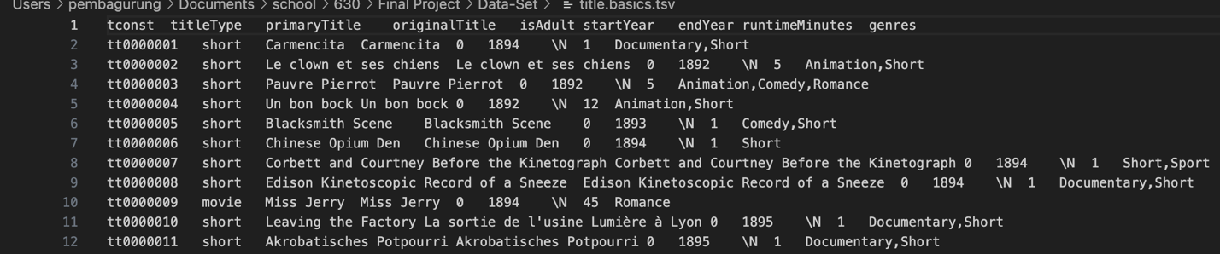
Schema: I downloaded a couple of datasets from the IMDB website to study the data schema. I have used a text editor to understand the schema and relationship among the tables. The images below show data and metadata of the ‘title.tsv’ and ‘rating.tsv’ (tsv: tab separate value). Files title.tsv and rating.tsv represents each table as the title and rating table.

Snapshot: title.tsv

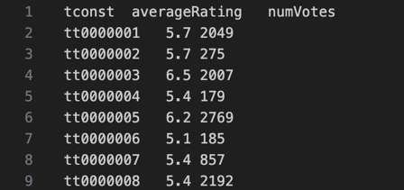

Snapshot: rating.tsv

Tables: Title table has columns as shown.

tconst | titleType | primaryTitle | originalTitle | isAdult | startYear | endYear | runtimeMinutes | genres
Data Type:
String - tconst, titleType, primaryTitle, originalTitle, genre,
Number - startYear, endYear, runtimeMinutes,
Boolean – isAdult

Rating table’s columns as shown.

tconst | averageRating | numVotes
Data Type:
String – tconst,
Number – averageRating, numVotes

Keys:

table | Primary key | Foreign key
title | tconst
rating | tconst | tconst

Relationship: These two tables bear a one-to-one relationship with ‘tconst’ as a primary key. A record of the title table is related to either one or none of the records of the rating table and a record of the rating table is related to only one record of the title table. In this relationship, we can see that the title table serves as a parent table and the rating table serves as a child. A record in the rating table can exist only when a corresponding parent record in the title table exists. Also noticed that the table title shares the primary key with the rating table.

Normalization: In the title table, the genre column has multiple values in a cell. Multiple values in a cell breaks a rule of 1NF. According to 1NF, the table should have a single-valued cell. To normalize the data to 1NF, I must separate values from the genre column to avoid multi-valued attributes in a cell. Before I began to work on queries to modify tables to the first normal forms, to visualize the data, I formatted the data of title.tsv in a new file manually in 1NF state. I realized that if the table is in a 1NF state, there will be duplicate rows with repeated keys and non-key attributes. The table would look like shown in the snapshot below.

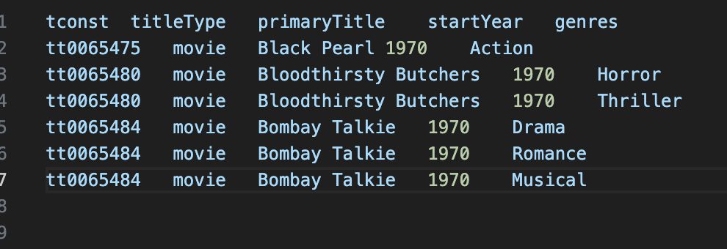

NOTE: The snapshot below does not contain all the columns from the original data file. As I mentioned, the data is filtered to achieve my ambitious goal.
This table now complies with the 1NF through 3NF definition. However, resolving multi-valued attribute issues raises multi-valued dependency issues. To fix the issue, the table needs to be in 4NF.
- Building Database for IDMB dataset:

After understanding the schema and relationship of these two tables, I used Oracle Data Modeler to create a DDL to create tables for the database. After the tables were created, I used import wizards to import the data from ‘title.tsv’ and ‘rating.tsv’.

ER-Diagram with Barker notation.

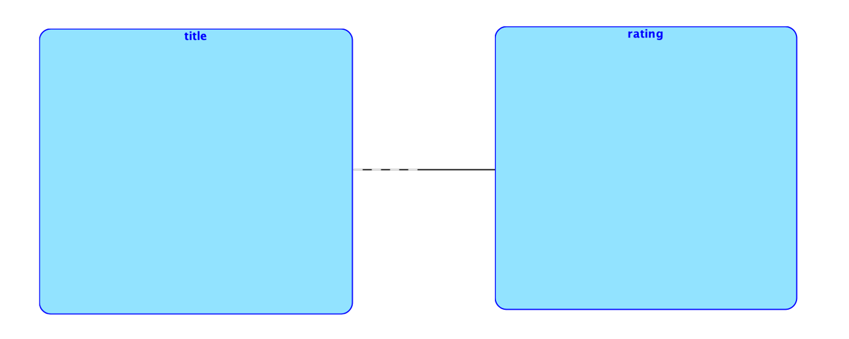
Logical Diagram

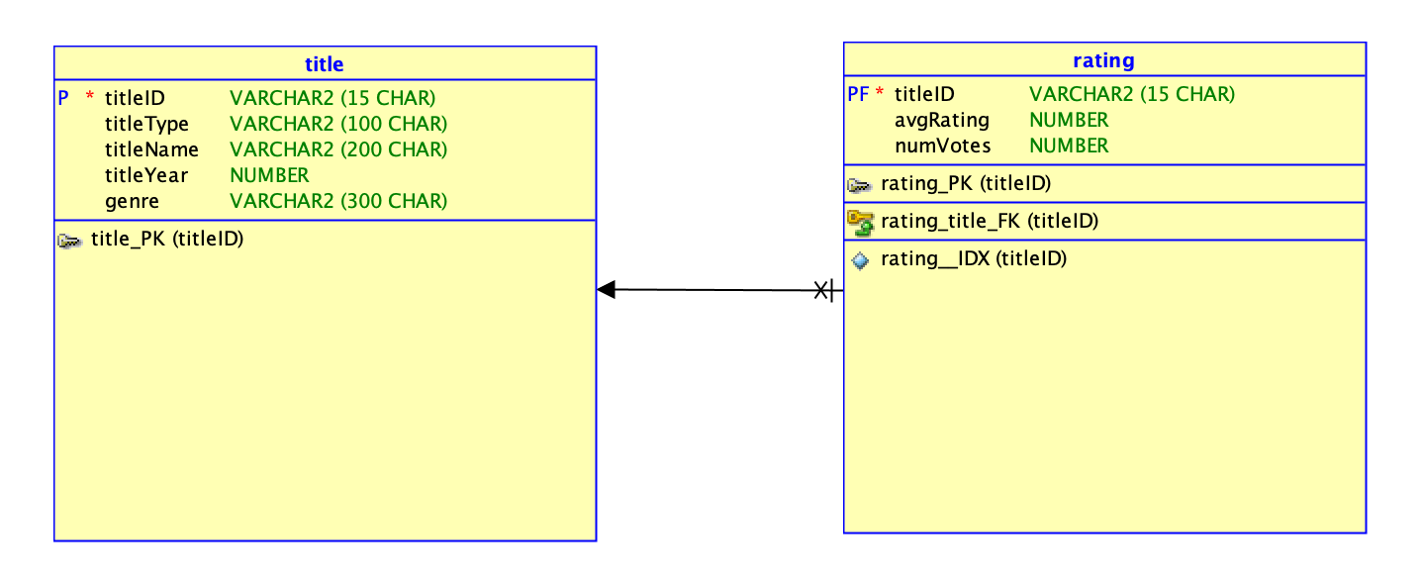
Relational Diagram

The index constraint in the rating table is to prevent duplication of combination values. In addition, the index speeds up the querying performance.

Creating tables using the generated .ddl file

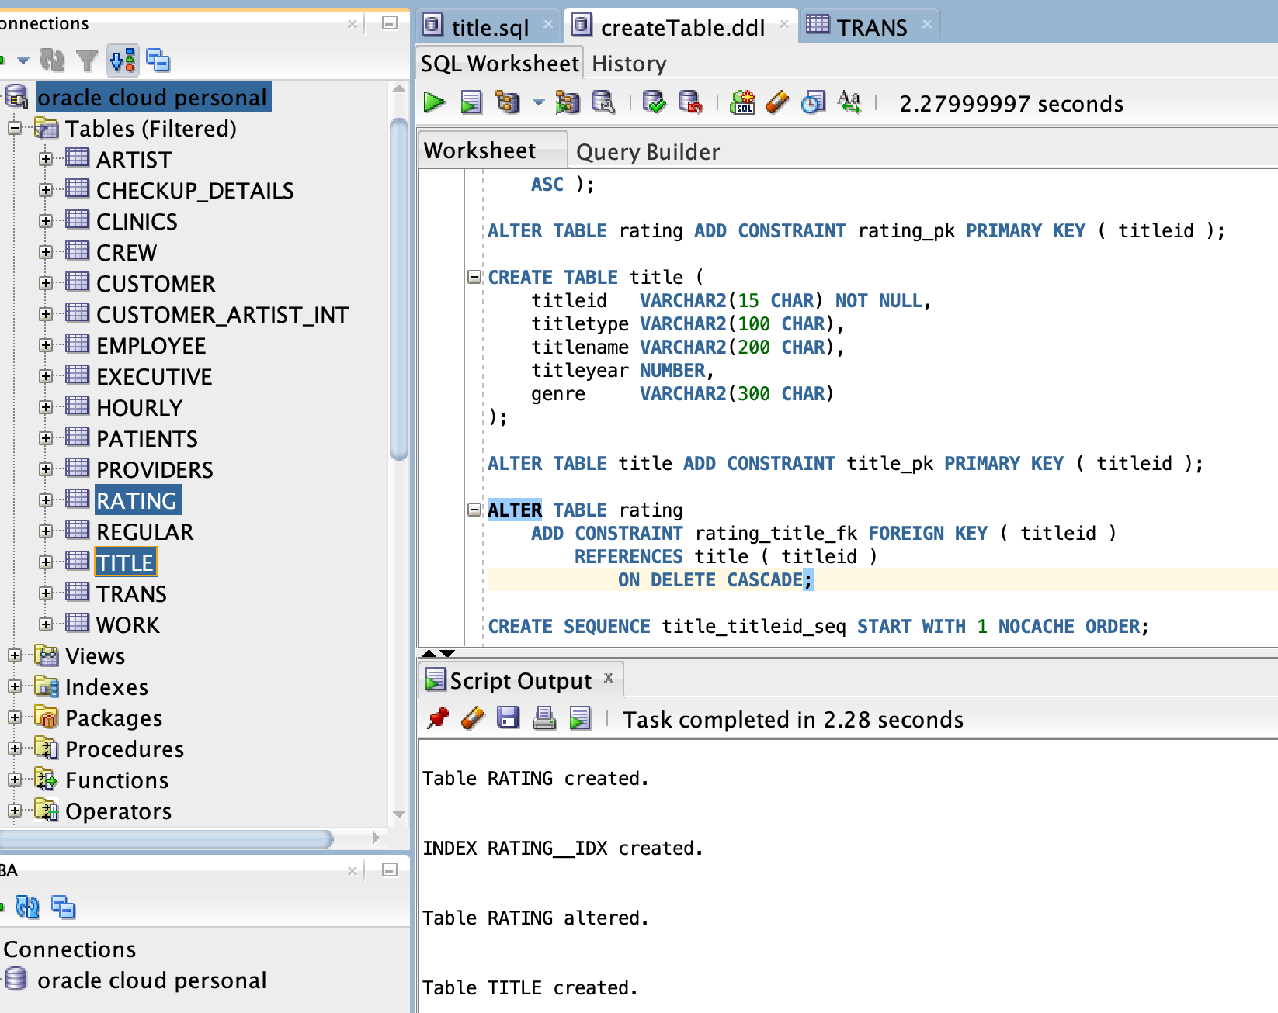

DDL script

- Database construction for IMDB dataset

CREATE TABLE rating (
titleid VARCHAR2(15 CHAR) NOT NULL,
avgrating NUMBER,
numvotes NUMBER
);

CREATE UNIQUE INDEX rating__idx ON
rating (
titleid
ASC );

ALTER TABLE rating ADD CONSTRAINT rating_pk PRIMARY KEY ( titleid );

CREATE TABLE title (
titleid VARCHAR2(15 CHAR) NOT NULL,
titletype VARCHAR2(100 CHAR),
titlename VARCHAR2(200 CHAR),
titleyear NUMBER,
genre VARCHAR2(300 CHAR)
);

ALTER TABLE title ADD CONSTRAINT title_pk PRIMARY KEY ( titleid );

ALTER TABLE rating
ADD CONSTRAINT rating_title_fk FOREIGN KEY ( titleid )
REFERENCES title ( titleid )
ON DELETE CASCADE;

CREATE SEQUENCE title_titleid_seq START WITH 1 NOCACHE ORDER.

CREATE OR REPLACE TRIGGER title_titleid_trg BEFORE
INSERT ON title
FOR EACH ROW
WHEN ( new.titleid IS NULL )
BEGIN
:new.titleid := title_titleid_seq.nextval;
END;
/

Import Data

To import data from a file, select the table where the data needs to be entered. Right-click/secondary click depending on Windows or macOS. Select import. The Data import wizards will pop up. Check the file format values are correct. For instance, header section, delimiter, etc.

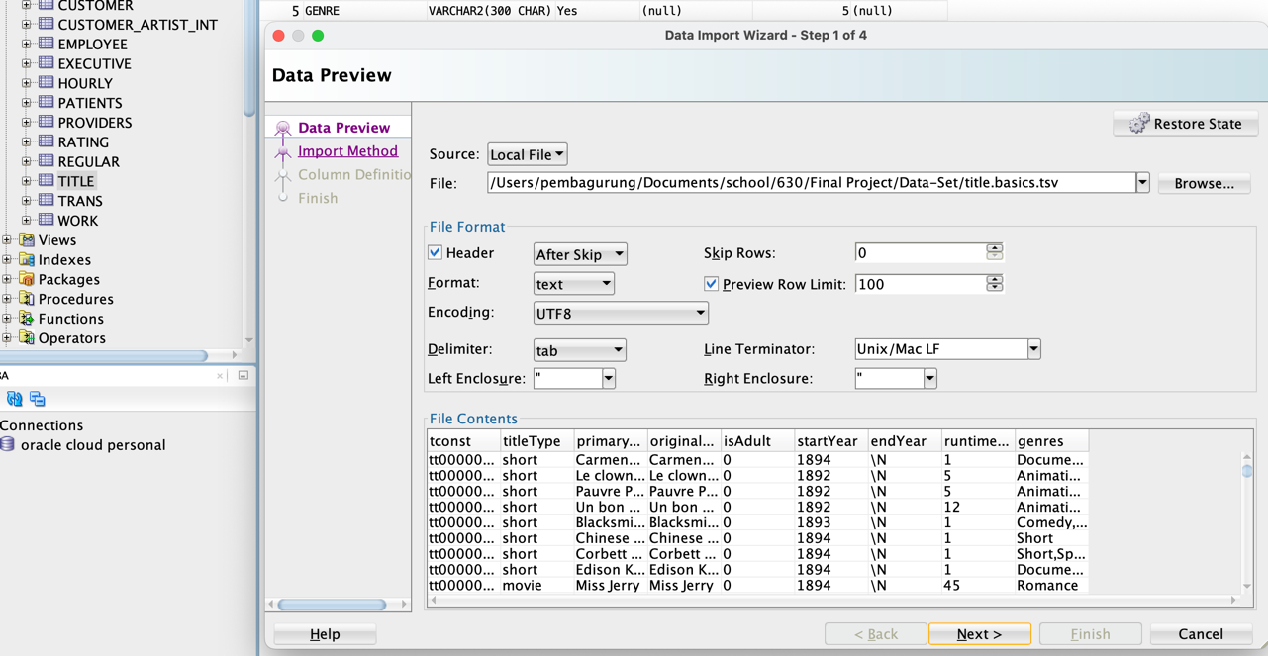

Click next and then select import method and import row limit.

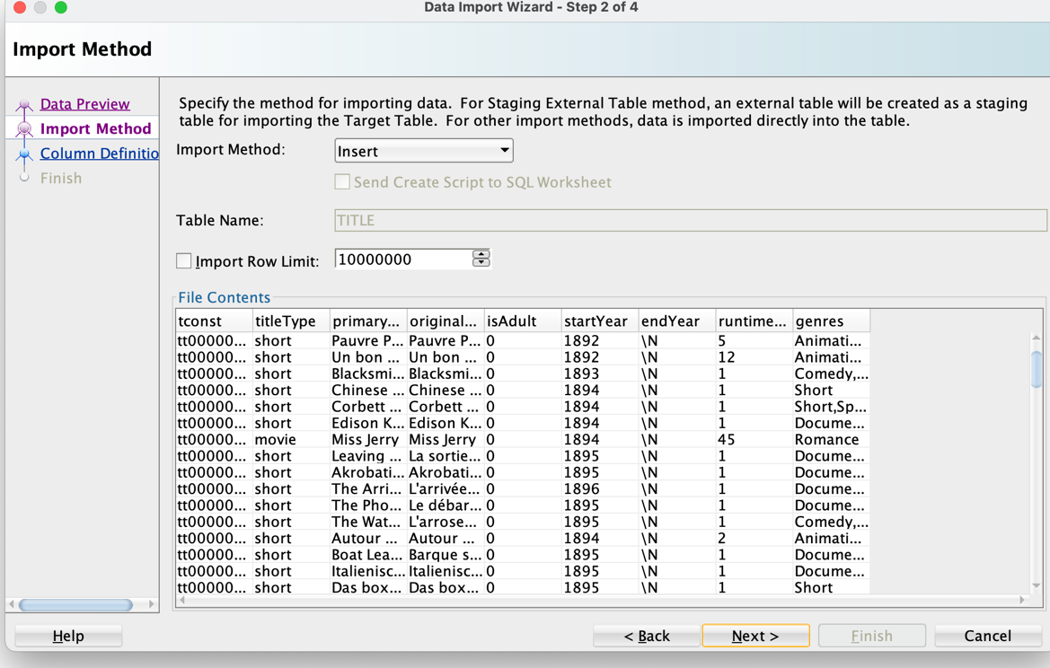

Click next and select fields to enter data into the appropriate fields. Box on the right side are the selected field’s names of the data file. For my “ambitious goal” for this project, I would like to filter columns for title table down to five columns from nine column of original data file.

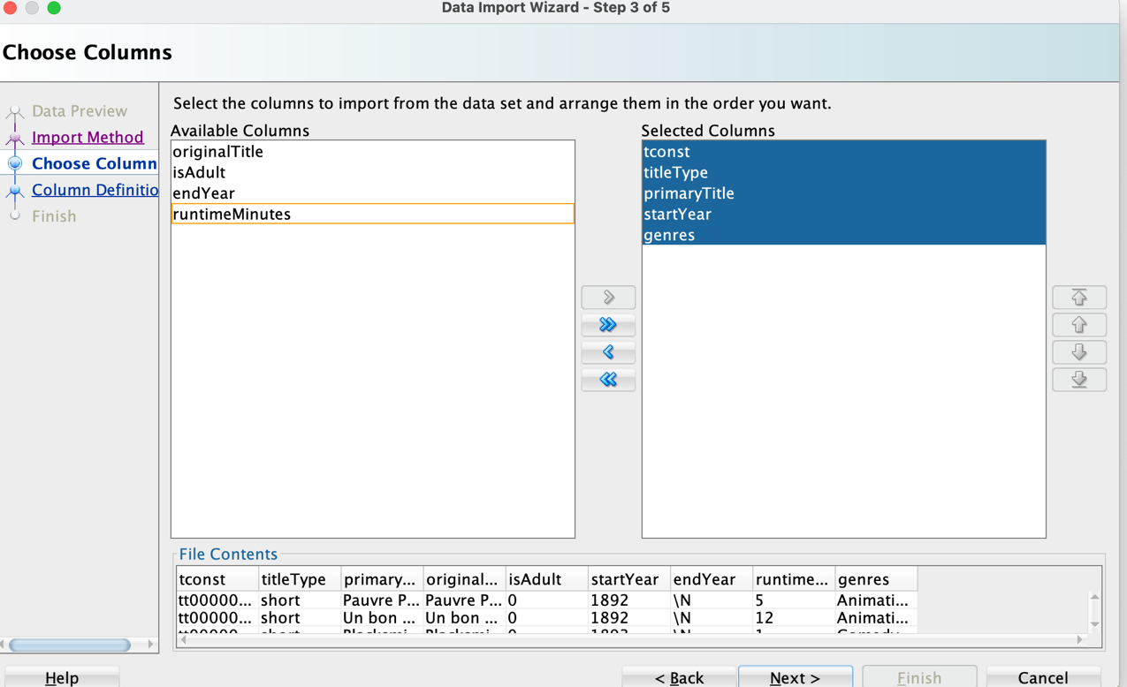

Click next and map the corresponding columns from data file to table fields. Select each column in source data column and match with appropriate target table column.
If there is red or yellow mark on a source data column, check the specific column in the target column and map the columns again.
If that doesn’t work, click on back button, and click next button again.

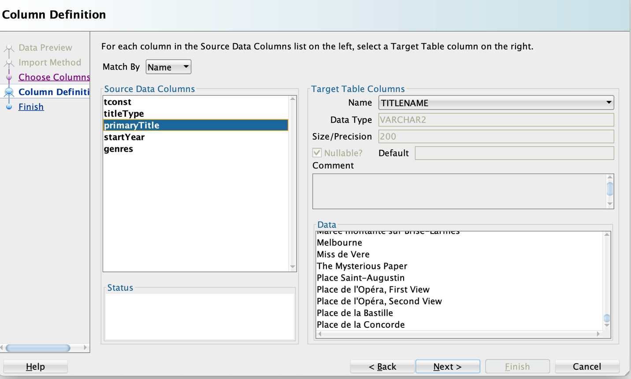

Click next and finish. If there’s an error import wizard will show errors message and action to be taken to resolve error. Import wizard will import the data otherwise.

Running the SQL commands in SQLDeveloper:
I used a data modeler application to engineer the DDL, but to allow the import wizard to insert data straight from the file (csv, tsv, etc.) in the correct columns in SQLDeveloper and to prevent the complication, I had to write DDL manually.
I tried running queries like create, insert, select, alter, and delete against the imported data. Some of the queries I ran against the database are listed below.
- /* Display all the column from title */
select * from title;

- /* Display title id, name and year of movies released in 2018 */
select titleid, titlename, titleyear from title
where titletype = 'movie' AND titleyear = 2018;

- /* Find the movie ‘The Shashank Redemption’ and display single column of title_name*/
select titlename from title
where titlename ='The Shawshank Redemption';

- /* Display all the column from rating*/
select * from rating;

- /* Show list of comedy movies that has IMDB scores greater than 8*/
select titlename from title
inner join rating
on title.titleid = rating.titleid
where title.titletype='movie' and rating.avgRating > 8 and title.genre = 'Comedy';

- /* Show list of movies name and year in ascending order that has more than 50000 votes and rating of more than 8*/
select titlename, titleyear from title
inner join rating
on title.titleid = rating.titleid
where title.titletype='movie' and rating.avgRating >8 and rating.numVotes > 50000
order by
title.titleyear ASC;

- Normal Form (1NF and 4NF)
To resolve the issue, the title table can be decomposed into movie and genre tables as shown in snapshots.
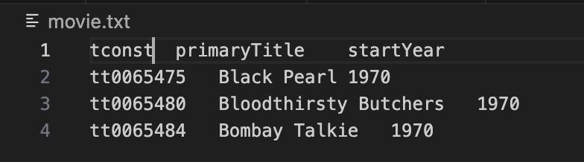

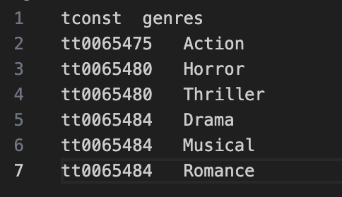
Designed database schema using data modeler.

To bring the old database (title table) to 1NF and then 4NF, I decomposed the title table to movie and genre tables. The information engineering notation is used for ER diagram.
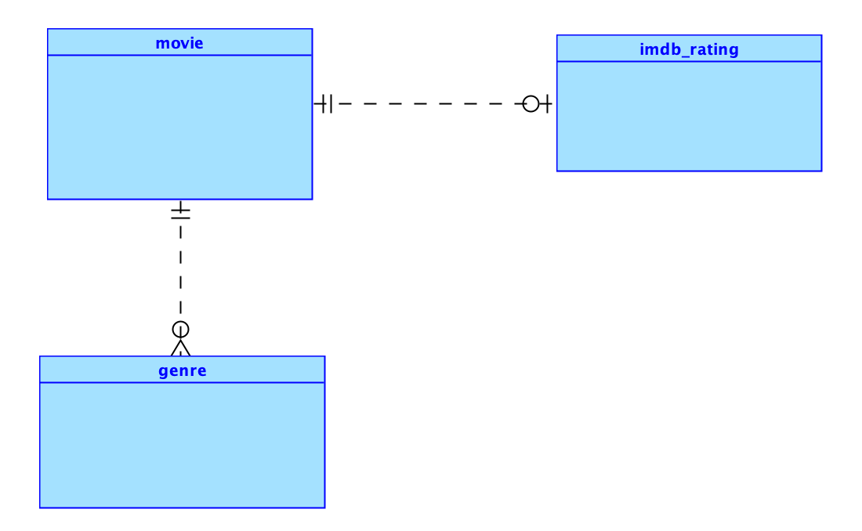
Figure: Logical Model

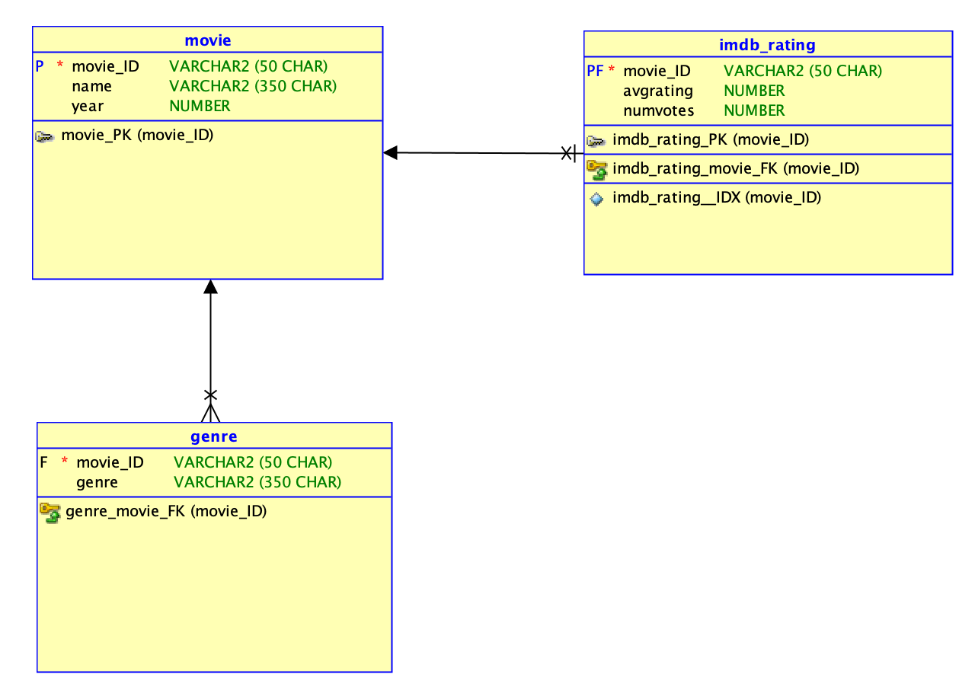
Figure: Relation Model
Relationship
Relationship between imdb_rating and movie table remains same as relationship between title and rating tables which one-to-one or none. The relationship of movie and genre is one to many since one movie has many genres.

DDL

/* genre table */
CREATE TABLE genre (
movie_id VARCHAR2(50 CHAR) NOT NULL,
genres VARCHAR2(350 CHAR)
);

/* imdbratings table */
CREATE TABLE imdb_ratings (
movie_id VARCHAR2(50 CHAR) NOT NULL,
avgrating NUMBER,
numvotes NUMBER
);

/* indexing on imdbrating and alter the table to add PK*/
CREATE UNIQUE INDEX imdb_ratings__idx ON
imdb_ratings (
movie_id
ASC);

ALTER TABLE imdb_ratings ADD CONSTRAINT imdb_ratings_pk PRIMARY KEY (movie_id);

/* movie table with PK */
CREATE TABLE movie (
movie_id VARCHAR2(50 CHAR) NOT NULL,
name VARCHAR2(350 CHAR),
year NUMBER
);

ALTER TABLE movie ADD CONSTRAINT movie_pk PRIMARY KEY (movie_id);

/* alter to add FK and Cascade delete rule */
ALTER TABLE genre
ADD CONSTRAINT genre_movie_fk FOREIGN KEY (movie_id)
REFERENCES movie (movie_id)
ON DELETE CASCADE;

ALTER TABLE imdb_ratings
ADD CONSTRAINT imdb_rating_movie_fk FOREIGN KEY (movie_id)
REFERENCES movie (movie_id)
ON DELETE CASCADE;

CREATE SEQUENCE movie_movie_id_seq START WITH 1 NOCACHE ORDER;

/* Trigger */
CREATE OR REPLACE TRIGGER movie_movie_id_trg BEFORE
INSERT ON movie
FOR EACH ROW
WHEN (new.movie_id IS NULL )
BEGIN
:new.movie_id := movie_movie_id_seq.nextval;
END;

Results of running DDL

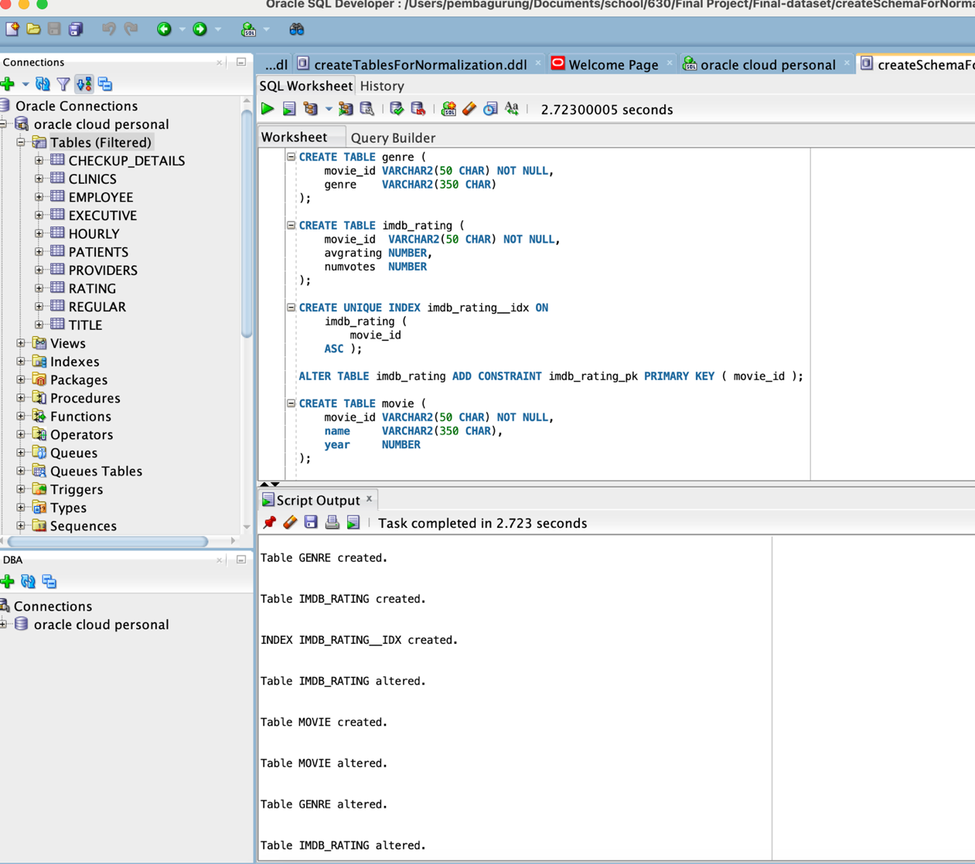
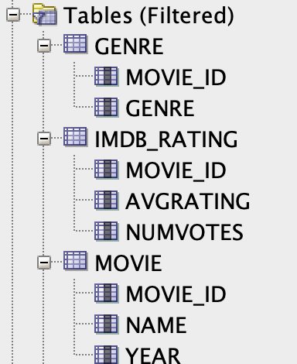
Data insertion (DML/DQL) with select statement.

/* inserts data from title table into movie table
where titletype is movie from 1970 or later with IMDB rating of 8+ score */

INSERT INTO movie (movie_id, name, year)
SELECT title.titleid, title.titleName, title.titleyear FROM title
INNER JOIN rating
ON title.titleId = rating.titleId
WHERE title.titletype='movie' AND rating.avgRating >=8 AND title.titleyear >= 1970;

-- Inserts data from rating into imdb_rating

INSERT INTO imdb_rating (movie_id, avgrating, numvotes)
SELECT rating.titleid, rating.avgrating, rating.numvotes FROM rating
INNER JOIN movie
ON movie_id = rating.titleId
WHERE rating.avgRating >=8;

/* Inserts data from title table to genre table
by splitting the multi valued column from title table
and enters each value into a cell from genre tables */

INSERT INTO genre (movie_id, genre)
SELECT titleid,
TRIM(REGEXP_SUBSTR(title.genre, '[^,]+', 1, LEVEL)) AS genre
FROM title
INNER JOIN movie ON movie.movie_id = titleid
CONNECT BY LEVEL <= REGEXP_COUNT(title.genre, ',') + 1
AND PRIOR titleid = titleid
AND PRIOR DBMS_RANDOM.VALUE IS NOT NULL;

NOTE: Inserting data for genre is a complicated task. To separate values from multi valued column in original table and store each of those value into a column of new table, I had to use combination of string manipulation functions and queries statement.

The bolded command such as follows are defined,
REGEXP_SUBSTR:
This function extracts each individual value from the genre column of the title table. The regular expression ‘[^,]+’ matches any sequence of characters that are not commas.
CONNECT BY LEVEL:
This is used to generate rows for each individual value extracted from the genre column.
TRIM:
This removes any leading or trailing spaces from the extracted values.

-- Deleting columns to create table space in db
alter table title
drop column titlename;
alter table title
drop column titleyear;
alter table title
drop column titletype;

Discovering

I have learned to use different features of applications, oracle data modeler, and SQLDeveloper platform such as import wizard features and how to tweak the memory limits for importing data to SQLDeveloper. I have improved at creating a DDL using Data Modeler and implementing it in SQLDeveloper.
My analysis skills to comprehend existing datasets have progressed with the help of database concepts like relational database models, design, ER-diagrams, relationships, keys, and normal forms. In addition, I learned how to modify tables using string manipulation functions and select queries.

Topics from class

- DML/DQL
The project involves DML and DQL implementation to build database. In the Building Database and normalization sections, DML likes to insert and delete commands, and DQL which is a select command is used to create the database. Further details are included under the Building Database and Running the SQL commands in SQLDeveloper.

- Relationships among tables
My observation includes the study of the relationship the tables for the IMDB dataset and how the relationship of those tables changes after normalizations. The sections Relationship.

- DB schema, keys, and design pattern:
Understanding a DB schema is key to creating a successful database management system. My notes for the IMDB data schema are under the Finding/Observation section. Moreover, I went over the keys and designs of the title and rating tables mentioned in the Finding/Observation section.

- Database construction/DDL:
Database design and data modeling concepts help create and organize database systems efficiently and effectively. I have used Oracle data modeler to replicate the design of the IMDB dataset tile and rating. I constructed a database to bring the title table to 1NF and 4NF. The details are mentioned in Building Database for IDMB dataset and Designed database schema using data modeler.

- Normalizations issues:
The IMDB dataset is well organized and designed thoroughly. However, the genre field of the title table has multi-valued attributes. The column could be in 1NF by separating all the values into its rows. However, modifying the title table to 1NF creates multi-value dependencies and breaks the 4NF rule. The details of the normalization processes for this project are mentioned in Normalization.

Challenges

Technical issues such as
- Oracle SQL developer memory issue - SQLDeveloper not being able to insert all the data and must keep deleting the columns or table to provide space for new tables.
- Sometimes after data insertion is completed the data gets erased or are not saved.
- Inserting data into genre table from title table was challenging.
Optimistic Objective:
- Connect the oracle.db with node.js to create a simple movie recommendation application.

Reference

IMDB dataset, https://datasets.imdbws.com

